Software Requirements Specification
A.B.C.D.E System
A patient-centered platform for Alamein Model Hospital

Structured per IEEE Std 830 / ISO-IEC-IEEE 29148
Version 2.0 · Draft for review · written after the site visit
Najd Al-Qimam for Information Technology

Document Control

Revision history
Ver. | Date | Author | What changed
1.0 | — | Najd Al-Qimam IT | First draft from the questionnaire and the feature list, before we had been to the hospital.
2.0 | June 2026 | Najd Al-Qimam IT | Rewritten after the site visit. The big changes were the three-way triage and the four ways patients actually arrive, the Serial built on the national ID and the two cards reception issues, the insurance check and the three-doctor committee, the rule about who may open the medical file, and what the IT team told us about DMS and the missing APIs. We also added the use cases, the data dictionary, the decision tables, the journey states, and the architecture and class diagrams.

Sign-off
Role | Name | Signature / date
Hospital sponsor (Deputy Director)
IT Department
Quality Department
Project lead (Najd Al-Qimam)
Confidential. Please keep it inside the named teams.

Contents

1. Introduction

1.1 Purpose
This is the specification for the A.B.C.D.E system we are building for Alamein Model Hospital: a patient app, a public website, and a set of staff dashboards that sit on top of the hospital's existing systems instead of replacing them. We wrote it after a day on site with the reception, nursing, IT, pharmacy, and radiology teams, and after working through an 83-question checklist with them. It is meant to be precise enough to build from and to test against, and honest about the few things we still need to confirm.

1.2 How to read this document
Functional requirements are numbered (FR-x.y) and use “shall” for things the system must do. After each one we note, in brackets, where it stands today and where it came from. The status is one of three words: Prototype means it already exists in the clickable patient-app mock-up; Partial means it is half-built or only sketched; Not built means it is described here and nothing has been written yet. Where a requirement matters or is easy to get wrong, we add a short Detail, Rules, or Acceptance note under it. Diagrams are numbered as figures and sit next to the part they explain.

1.3 Who should read what
If you are building it, read Sections 3 to 6. If you are from the hospital, Sections 1, 2, and 4 will be the most useful, plus the business rules in Section 8. If you are reviewing quality or running the project, Sections 2, 7, and 9 cover you.

1.4 Scope
The system follows a patient from the moment they arrive until they go home and beyond, and the case we keep coming back to is the heart-attack patient who ends up in cardiac catheterization. There are three things to build: the patient mobile app (tracking the visit, an AI advisor, medication, appointments, reports, family access, feedback, indoor navigation, accessibility), the public website (information and an appointment request for people without an account), and the staff dashboards (doctor, nursing, reception, family, quality, administration, emergency).
Two things are explicitly out of scope for now. We are not replacing DMS, the hospital's main system; we work alongside it. And we are not doing medical-imaging AI (reading X-rays, ECGs, or CT scans) in the early releases — that needs data, regulatory work, and clinical validation we do not have yet.

1.5 Terms we use
Term | What it means here
DMS | The hospital's existing system. It runs registration, appointments, the clinical workflows, the lab, and administration.
Serial | The patient's medical number. It is built from the national ID, it is sequential (not a QR code), and the same number is used in Emergency and in Outpatient so a patient's records pile up under it.
Triage | The first look by a head nurse, who sorts the patient into Cold, Emergency, or Critical.
Cold state | Anything that is not urgent — an outpatient visit, or a planned operation.
Door-to-Balloon | The hospital's headline cardiac number: how long from the patient arriving (door) to the balloon being inflated in catheterization (balloon).
Risk Score / RSTP | The deterioration / catheterization risk score; RSTP is the version used when a patient is moved between departments. It is redone every week while the patient waits or stays.
Three-Doctor Committee | Three physicians who, for a life-threatening case with no information, authorize immediate treatment and take responsibility; and who separately review the money side when a patient has no insurance and cannot pay.
NEWS2 / MEWS | Standard early-warning scores. We use these first rather than training our own model.
RAG | Retrieval-augmented generation — keeping the AI's answers tied to content the hospital has approved.

1.6 Sources
- The site-visit notes (English) and the detailed reception/journey notes (Arabic).
- The 83-question requirements checklist: website (Q1–Q12), the heart-attack journey under the eight patient-centered-care principles (Q13–Q46), and dashboards, roles, emergency, and the existing systems (Q47–Q83).
- The feature and AI-model write-ups, and the hospital's own forms: the clinics workflow, the catheterization workflow, the dental / gyn / pediatric forms, and the eleven-section patient file.

2. The system in context

2.1 Where it sits
The platform is a layer on top of what the hospital already runs, not a replacement. A few facts from the IT walkthrough shape everything else, so they are worth stating plainly:
- DMS is the main system. The lab is fully wired into it: a doctor's lab order goes out and the result comes back through DMS.
- Radiology is a different system. The IT lead called it “Milestone”; we still need to confirm the exact name.
- The pharmacy is connected to DMS but a good part of it is still done by hand.
- There are no integration APIs today. They can be bought from the DMS vendor, but until then we work off an external server reachable through an IP whitelist on the hospital LAN, and we build against API documentation with dummy data.
- Monitoring devices are not on the network. Only radiology and the labs feed the system, so vital signs are typed in by the nursing staff, and the early-warning logic works off those manual readings plus lab values.
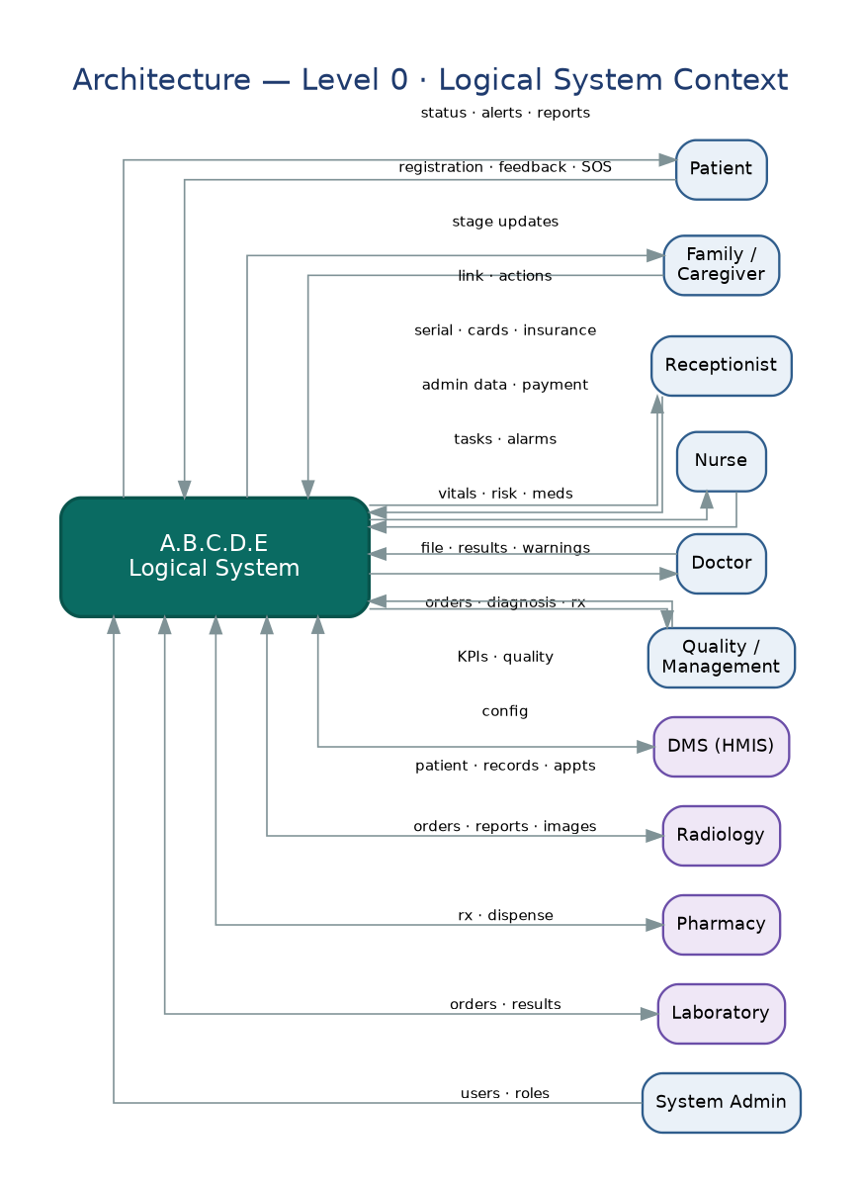
Figure 1. System context (Level 0). The platform as one box, the people and outside systems around it, and the main things flowing in and out.
Inside that box the application is a fairly ordinary Laravel app: requests come in through routes and controllers, the work happens in a service per subsystem, and data is read and written through repositories onto Eloquent models and MySQL. Cross-cutting things (events, queued jobs, notifications, authorization policies) and the integration adapters to DMS, radiology, and pharmacy sit to the side.
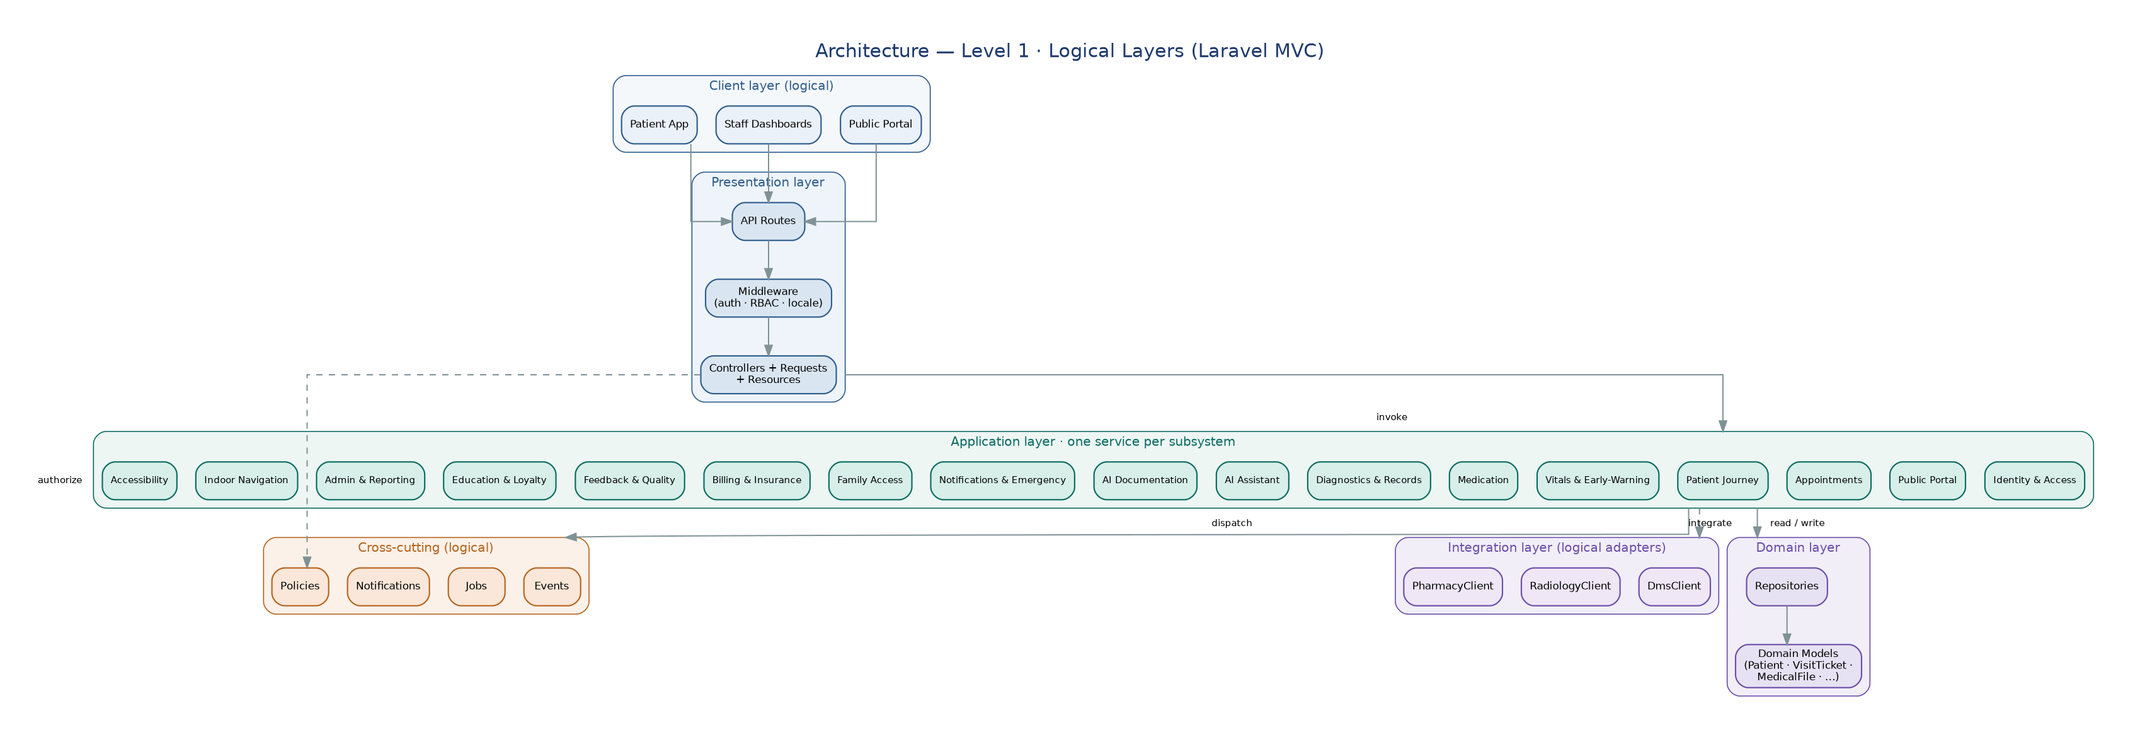
Figure 2. Architecture (Level 1). The clients, the Laravel MVC layers, the seventeen subsystem services, and the integration adapters.

2.2 What it does, in one paragraph
It identifies the patient and issues their Serial; shows hospital information to visitors; books and reschedules appointments; tracks the patient through the visit across all four arrival paths; records vitals and scores risk; manages medication; keeps the full record; runs an AI advisor and helps with documentation; sends notifications and runs emergency escalation; lets a chosen family member follow along within the privacy rules; sorts out insurance and billing; collects feedback and turns it into quality reports; teaches and rewards; administers users, reports, and integration; and helps people find their way inside the building. Section 5 takes each of these apart.

2.3 Who uses it
Most patients here are from Matrouh, from the nearby tribes, or workers on the North Coast, and plenty of them are not used to apps. That is why a plain, bilingual, accessible interface is a requirement and not a nicety. The roles are:
Role | What they do | What they can see
Patient | Receives care; follows their own visit. | Their own record; can leave feedback
Family / caregiver | A linked companion who follows and may act for the patient. | Status only; more if granted
Guest | A visitor with no account. | Public information only
Doctor | Diagnoses, prescribes, orders tests, moves the patient along. | Their own patients' full file
Nurse / nursing supervisor | Takes vitals, gives medication, works out the risk score. | Vitals/meds; the supervisor sees the file
Receptionist | Registers patients, issues cards, handles admin and payment. | Administrative data only
Quality manager | Goes through feedback, complaints, and reports. | Quality data and summaries
Department head | Gets the negative feedback and complaints for their department. | Their department
Hospital director | Reads the KPIs and the monthly reports. | Cross-department summaries
System / IT admin | Creates accounts, sets permissions, runs the integration. | Admin only, no clinical content
Three-doctor committee | Authorizes life-saving treatment and reviews unfunded cases. | Just the case in front of them

2.4 What constrains us
- Reception touches administrative data only. It never edits anything medical.
- The medical file is for the treating doctor and the nursing supervisor. Family cannot see it, and each department sees only its own part.
- There are no APIs yet, so for now the platform is the source of truth for whatever it collects.
- Vitals are typed in by hand; there is no device feed to lean on.
- The ambulance radio call and the readings taken in the ambulance are not recorded and not trusted — vitals are taken again in the ER.

2.5 Assumptions and dependencies
- The DMS vendor APIs will be bought; when and at what cost is outside our control.
- Two small things are still open: the real name of the radiology system (“Milestone”?) and where the third pharmacy is.
- We validate against one real, anonymized heart-attack case and clear the hospital and ethics approvals before any live pilot.

2.6 Release plan
Release | What is in it
R1 (now) | The clickable patient-app prototype.
R2 | Staff dashboards; billing and insurance; vitals and early warning; the record; notifications and emergency.
R3 | The first AI features (advisor, feedback reports, report drafts); DMS integration once the APIs exist.
R4 | Indoor navigation and accessibility.
Later | Medical-imaging AI.

3. External interfaces

3.1 People-facing
The patient app is mobile-first, with a five-tab bottom bar (Home, Journey, Advisor, Care, Learn), Arabic or English depending on the patient's choice, and the accessibility behavior in Section 5.17. The dashboards are web screens, one shape per role, gated by the permission rules in FR-1.7 and FR-1.8. The public site works without a login.

3.2 Hardware
Indoor positioning uses BLE beacons and/or Wi-Fi. Nothing clinical is wired in; vitals are typed.

3.3 Other software
System | Where it stands | What we need from it
DMS | Main system, no APIs yet | Bought APIs for registration, appointments, the record, clinical notes, and admin.
Lab | In DMS | Lab orders and results read through DMS.
Radiology | Separate (“Milestone”, to confirm) | Its own interface for orders, reports, and images; respect the category that decides who gets films.
Pharmacy | In DMS, half-manual | Read prescriptions and dispensing now; real-time stock and alternatives later.

APIs we will ask the vendor for
Authentication (login, logout, verify a patient); Patient (read and update the profile); Appointment (book, cancel, reschedule, history); Records (diagnoses, plans, notes); Lab (orders, results, report download); Radiology (orders, reports, images); Pharmacy (medication list, history, availability, alternatives); Billing (payments, invoices, coverage); Notification (reminders, result alerts, plan updates).

3.4 Network
Everything talks over the hospital LAN. The application server is reachable only through an IP whitelist. Patient notifications go out on whatever channel the patient picked. The ambulance pre-alert stays a phone/radio call, outside the system.

4. How it is used
These are the flows we watched and were walked through on the day. They are the spine that the requirements in Section 5 hang off.
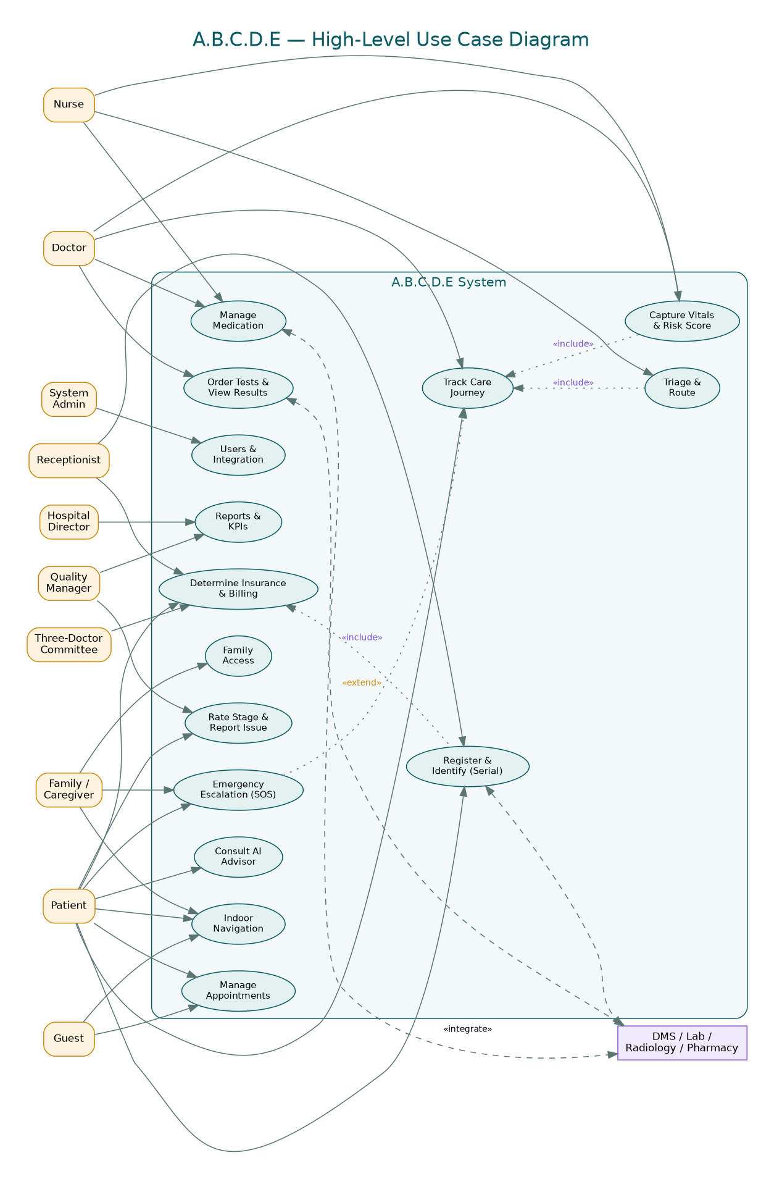
Figure 3. High-level use cases: who does what with the system, and where it touches the outside systems.

UC-1 — Heart-attack patient brought in by ambulance, ending in catheterization
Main actor: ER physician Also involved: patient, family, cardiologist, nursing, reception, billing
Before: The patient is on the way in by ambulance; the heart-attack path is set up. Starts when: the ambulance crew radios ahead.
What happens:
- The crew radios the patient's state. That call is verbal and is not recorded anywhere in the system.
- On arrival the patient goes straight into the ER room, not the triage room. Three things happen at once: the ER doctor starts examining, the nurse takes the vitals again because the ambulance readings are not trusted, and the family go to reception with the paperwork.
- Reception opens a file and makes a Serial from the national ID. Insurance is worked out from the same ID (UC-5).
- The ER doctor sees a cardiac problem, orders an Echo and an ECG straight away, and looks at the results.
- The patient is sent to Cardiology; the cardiologist examines and decides on catheterization.
- The case turns Cold and shifts onto the operations track: a physical file is opened, the cardiologist lists what the procedure needs in the requisition book, the patient goes on the operations list, and the nurse works out the risk score (redone weekly while waiting).
- The catheterization is done; the findings are written up; the Door-to-Balloon time is recorded.
- Afterwards the patient is watched, may go to cardiac ICU, and a closing financial file is issued.
When it goes differently:
- If the patient arrives in arrest, they go straight to resuscitation, not the ER room.
- If they are unconscious with nobody, the crew tries to identify them from anything on them; the paperwork is done later.
- If they have no insurance and cannot pay but the case is life-threatening, they are admitted at once and the money is sorted out afterwards by the committee (UC-5).
After: The patient has a Serial, a full file, a recorded Door-to-Balloon time, and a follow-up plan.
Touches: FR-1.4, FR-4.2–4.5, FR-5.1, FR-7.1–7.3, FR-10.2, FR-12.1–12.3, FR-15.2

UC-2 — Awake emergency patient who comes in with family
Main actor: Triage head nurse Also involved: patient, family, ER physician, specialist
Before: The patient walks (or is helped) into the ER with relatives. Starts when: they reach the triage room.
What happens:
- Two things at once: the nurse takes vitals, and reception collects the admin data from the patient or family.
- Insurance is checked, a file is opened, and a Serial is issued from the national ID.
- The ER doctor in the triage room examines, sorts the case, and refers to the right specialty.
- For a suspected cardiac case, an Echo and an ECG are ordered.
- The specialist examines and decides treatment, and from here it runs like UC-1 from step 6.
When it goes differently:
- If triage decides it is Cold and the clinics are open, the patient is sent to the right outpatient clinic (UC-3).
After: The patient is seen, sorted, and sent to the right specialty under one Serial.
Touches: FR-4.2–4.4, FR-5.1, FR-7.1, FR-1.4

UC-3 — Outpatient (cold) clinic visit
Main actor: Outpatient physician Also involved: patient, nurse, reception, IT
Before: A non-urgent complaint, during clinic hours. Starts when: the patient turns up in person — there is no phone booking.
What happens:
- Reception takes the usual admin and basic medical data and issues a Serial.
- Insurance is checked (UC-5).
- Before the clinic, the nurse records vitals.
- In the clinic the doctor records vitals, writes the complaint into the problem list, checks allergies, and sets the diagnosis on the right form (dental, gyn, or pediatric).
- Any tests go to the lab; any prescription goes to the pharmacy.
- It all lands on the patient's sheet for next time.
- The findings are written on paper first, then keyed into the system by IT.
When it goes differently:
- If the case turns out to be serious, the doctor can admit the patient, who then moves to the right department with the same data and a different set of steps.
After: A finished clinic record under the Serial, with tests and prescriptions on their way.
Touches: FR-2.5, FR-3.x, FR-4.7, FR-6.1, FR-7.1, FR-7.4

UC-4 — Booking a planned operation (cold state)
Main actor: Treating surgeon Also involved: patient, nurse, operations scheduler, billing
Before: The patient has already been examined here — this is a hard rule. Starts when: an operation is decided.
What happens:
- A physical file is opened with all the patient's data.
- The patient goes onto the operations list.
- The surgeon writes everything the operation needs into the requisition book, so it can be bought beforehand.
- The nurse works out the risk score; it is redone every week through the wait and the stay.
- After the operation, a closing financial file is issued with the full cost.
When it goes differently:
- No prior examination here means no booking — the request is refused.
After: The operation is scheduled, the supplies are requisitioned, the risk is tracked, and the money closes out.
Touches: FR-3.6, FR-4.5, FR-5.4, FR-12.6

UC-5 — Working out insurance at reception
Main actor: Receptionist Also involved: patient, billing, three-doctor committee, administration
Before: The patient is being registered. Starts when: reception types in the national ID.
What happens:
- The system looks up the insurance status and comes back with one of four answers.
- Insured: registration carries on normally.
- Has an employer who pays: carries on normally.
- No insurance but can pay: the patient pays; carries on normally.
- No insurance and cannot pay: the three-doctor committee looks at the case and a memo goes up to the authorities about state funding.
When it goes differently:
- For a life-threatening case the patient is admitted right away whatever the answer, and the money is dealt with later.
After: The insurance status is on the file and the right billing path is chosen.
Touches: FR-12.1–12.3

UC-6 — Raising the alarm from the app
Main actor: Patient or family Also involved: treating physician, nursing station, family contact, care center
Before: The patient (or a permitted family member) is signed in and a care episode is open. Starts when: the SOS is triggered, by tap or by voice.
What happens:
- The app shows the four people who will be alerted, in order: treating physician, nursing station, family contact, care center.
- On confirm, the first one is alerted.
- If nobody answers within the set wait, it moves to the next.
- A real emergency (needs intervention now) is told apart from a normal heads-up and routed accordingly.
When it goes differently:
- The SOS can be fired by voice, for accessibility.
- A Code Blue runs the same chain with no confirm step.
After: The right people are reached, in order, with automatic escalation if no one answers.
Touches: FR-10.2–10.5, FR-17.2

5. What each part must do
One subsystem at a time: what it is for, who uses it, the numbered requirements, and a diagram of its inside down to the class level.

5.1 Identity, Access & Onboarding
What it is for. It works out who someone is, creates the patient's identity, and holds the line on who can see what. Priority High; today it is Partial.
Who uses it. Patient, family, guest, receptionist, system admin
FR-1.1 The system shall log a user in by mobile number or file ID and a password, and lock the account for a short while after repeated failures. [Partial · Q3, Q13]
  - Rules: Five failures in a row locks the account for five minutes.
  - Acceptance: Right credentials return a session in the right role; an expired session forces a fresh login.
FR-1.2 The system shall accept a QR-code login that resolves to the patient's Serial on the server. [Partial · Features]
FR-1.3 The system shall let guests look around read-only and ask them to sign in the moment they open a personal area. [Prototype · Q3]
FR-1.4 The system shall make the Serial from the national ID the first time it meets a patient and reuse it on every later visit, so the records gather under one number. [Not built · Q13, reception study]
  - Detail: Sequential, from the national ID, not a QR code; the same in Emergency and Outpatient.
  - Rules: A national ID that already exists is caught, so nobody gets a second Serial.
  - Acceptance: A returning patient's old diagnoses and prescriptions come up by Serial.
FR-1.5 The system shall issue two cards at Emergency — an arrival card and a booking card — each built from the national ID. [Not built · Reception study]
  - Detail: Arrival card (one copy, on arrival): serial, registration number, name, date/time, barcode.
  - Detail: Booking card (several copies, once booked): serial, age, date of birth, name, barcode.
FR-1.6 The system shall keep the patient's preferences (language, how to reach them, any religious, cultural, or dietary note) and a named decision-maker. [Partial · Q14–Q16]
  - Rules: The chosen language drives every notification.
  - Rules: The decision-maker may consent when the patient cannot.
FR-1.7 The system shall define roles and enforce who can view and who can edit, screen by screen and field by field. [Not built · Q47–Q51]
FR-1.8 The system shall keep the medical file to the treating doctor and the nursing supervisor, keep reception to administrative data, and show each department only its own part. [Not built · Reception study]
  - Rules: No permission lets family open the medical file.
  - Rules: Reception can never edit anything medical.
  - Acceptance: A reception login cannot see clinical fields; a doctor sees only their own patients.
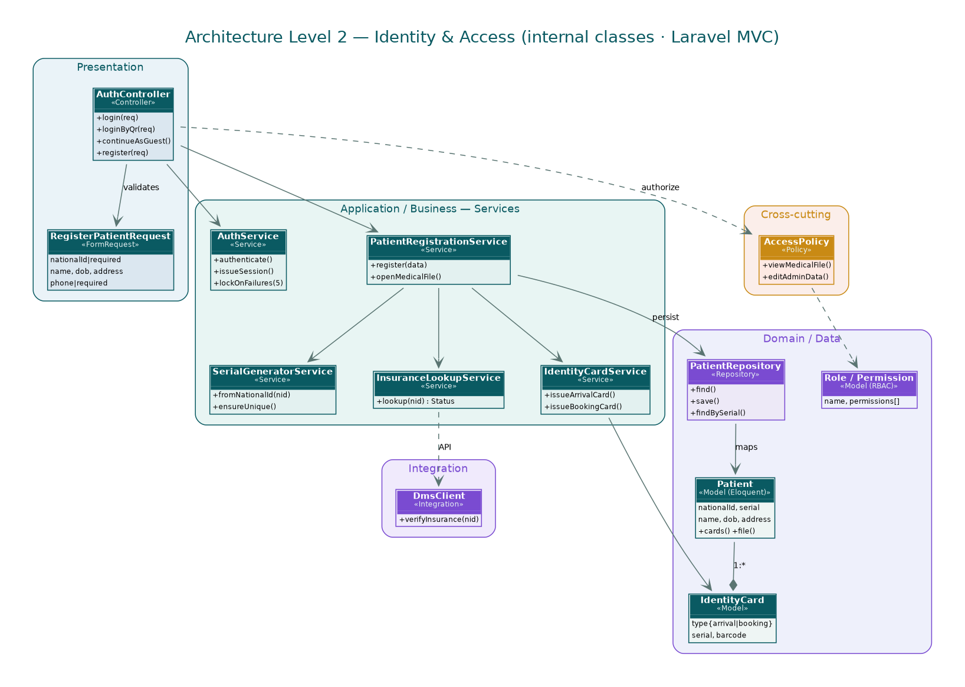
Figure 4. Inside Identity, Access & Onboarding — controllers, services, repositories, and models, with the calls between them.

5.2 Public Portal & Discovery
What it is for. It shows the hospital to people who do not have an account, and opens the door to booking. Priority Medium; today it is Prototype.
Who uses it. Guest
FR-2.1 The system shall show the hospital profile, the contacts, and any intro videos. [Prototype · Q1, Q2]
FR-2.2 The system shall list every department and clinic with its services and hours. [Prototype · Q8–Q10]
  - Rules: Booking is offered only inside the listed hours; Emergency is always open.
FR-2.3 The system shall give a searchable list of doctors with name, specialty, and an optional photo and short bio. [Prototype · Q11, Q12]
FR-2.4 The system shall publish hospital news and patient stories, newest first. [Prototype · Q3]
FR-2.5 The system shall take an appointment request online — something the hospital cannot do today, since booking is in person only. [Partial · Q4, reception study]
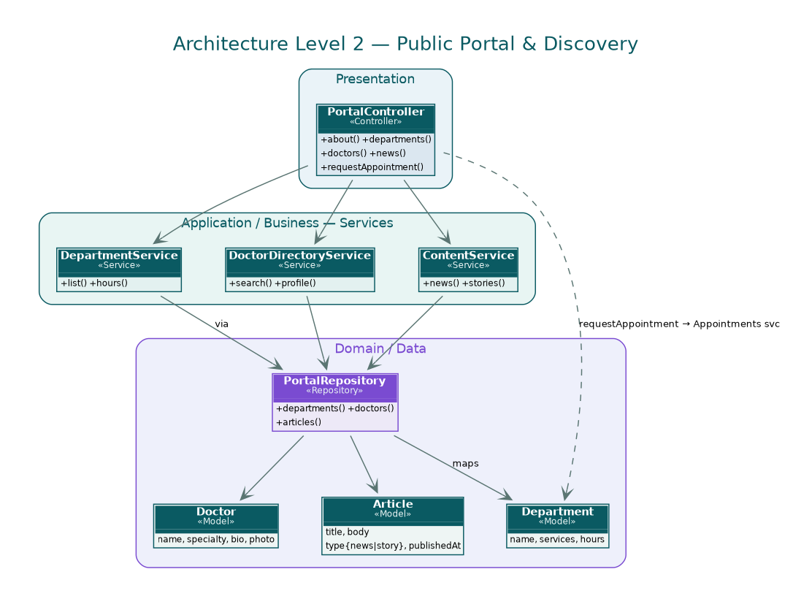
Figure 5. Inside Public Portal & Discovery — controllers, services, repositories, and models, with the calls between them.

5.3 Appointments & Scheduling
What it is for. It lets patients ask for, see, and move appointments inside the hospital's rules. Priority High; today it is Partial.
Who uses it. Patient, guest, family, receptionist, doctor
FR-3.1 The system shall take an appointment request with name, phone, department, complaint, and preferred time. [Partial · Q4]
  - Rules: All five are required; the request joins the department's queue.
FR-3.2 The system shall build the open slots from each department's hours. [Partial · Q10, Q22]
  - Detail: Slots are fifteen minutes; each clinic has a daily cap set per department.
FR-3.3 The system shall show upcoming appointments with doctor, department, room, and time. [Prototype · Q46]
FR-3.4 The system shall let a patient move an appointment up to a cut-off and cancel within the rules. [Partial · Q23]
  - Rules: Moving it is blocked inside the cut-off window.
FR-3.5 The system shall keep each admitted patient to one treating doctor at a time. [Not built · Schedule]
FR-3.6 The system shall allow a planned operation to be booked only after the patient has been examined here. [Not built · Operations pathway]
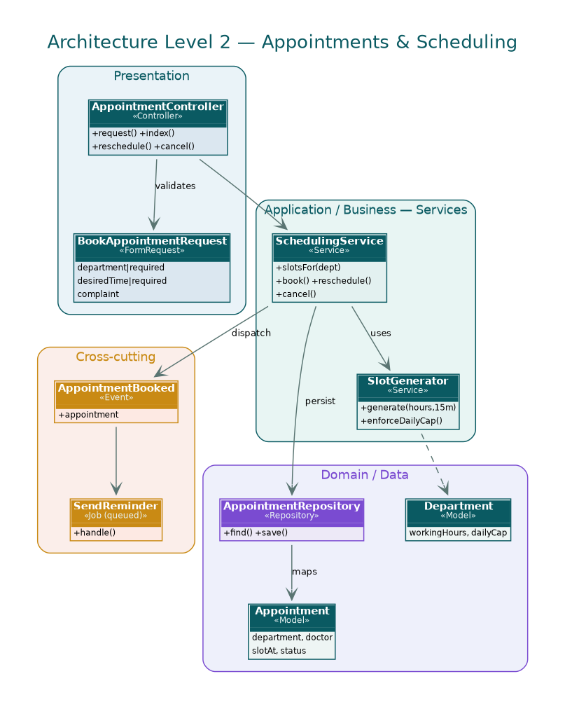
Figure 6. Inside Appointments & Scheduling — controllers, services, repositories, and models, with the calls between them.

5.4 Patient Journey & Care Coordination
What it is for. It follows the patient through the visit on one shared ticket, whichever way they came in. Priority High; today it is Prototype.
Who uses it. Receptionist, nurse, doctor, patient, family
FR-4.1 The system shall open a ticket on arrival with a number, a starting stage, and an anonymized code. [Prototype · Q33]
FR-4.2 The system shall record the triage class the head nurse gives and route on it. [Not built · Site visit]
  - Detail: Cold (not urgent), Emergency (urgent), Critical (unconscious, accident, life-threatening).
  - Rules: Critical skips triage and goes straight to Emergency.
  - Rules: Cold during clinic hours goes to the clinic; outside hours, to reception.
FR-4.3 The system shall run a branching stage engine that covers the four arrival paths, not one straight line. [Partial · Reception study]
FR-4.4 The system shall allow vitals and registration to be done at the same time on arrival. [Not built · Reception study]
FR-4.5 The system shall carry the cold-state operations track: physical file, requisition book, weekly risk score, closing financial file. [Not built · Operations pathway]
FR-4.6 The system shall give each stage an owner who moves the patient on, and allow exception paths. [Partial · Q34–Q37]
  - Detail: The stages, owners, and transitions are in the state table in Section 6.4.
FR-4.7 The system shall show the patient a plain status for each stage (“being assessed”, “in the procedure”, “stable”). [Prototype · Q17, Q18]
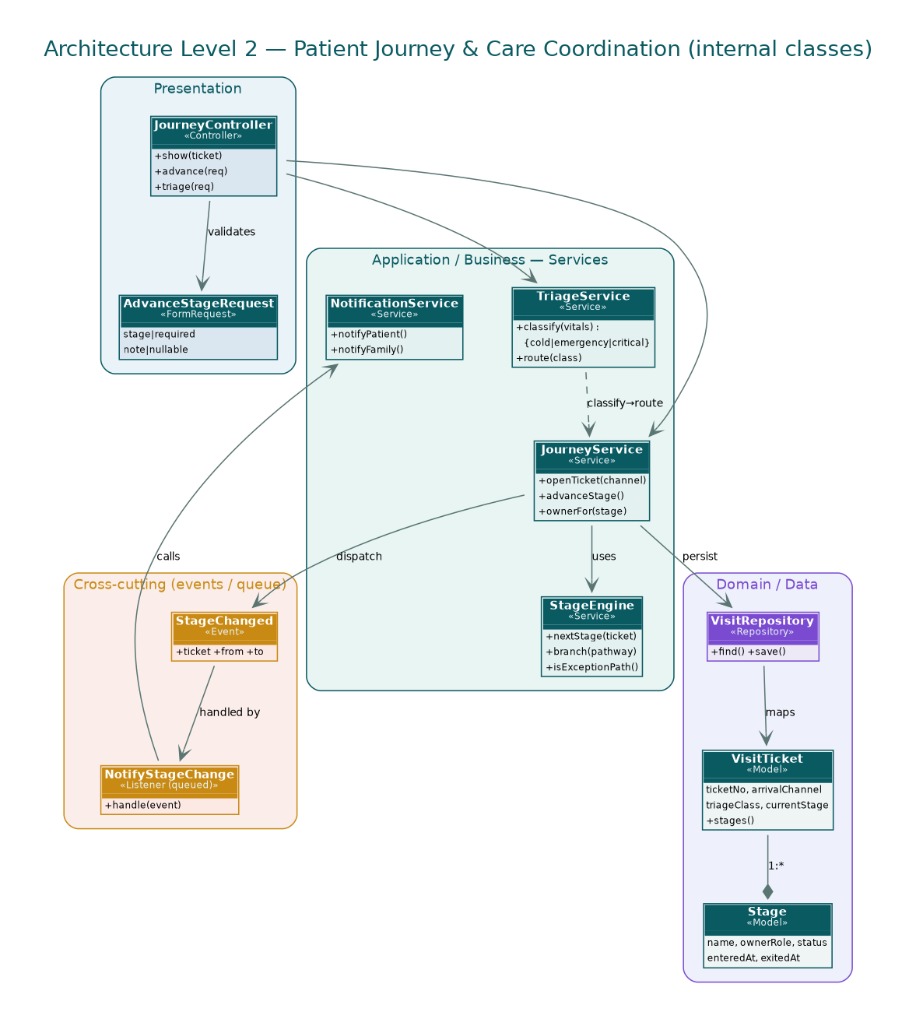
Figure 7. Inside Patient Journey & Care Coordination — controllers, services, repositories, and models, with the calls between them.

5.5 Vitals Monitoring & Early Warning
What it is for. It records vitals and gives the team a warning before a patient slides. Priority High; today it is Not built.
Who uses it. Nurse, doctor
FR-5.1 The system shall take vitals by hand, since the monitors are not on the network. [Not built · Site visit]
  - Detail: At least pulse, blood pressure, and SpO2.
  - Rules: How often is set per stage (for example, hourly in the care unit).
FR-5.2 The system shall hold a threshold per vital and raise an alert when one is crossed. [Not built · Q39]
  - Acceptance: A blood pressure under the set floor alerts the responsible staff.
FR-5.3 The system shall score deterioration with NEWS2 or MEWS in the first version. [Not built · AI models]
FR-5.4 The system shall redo the risk score weekly through the wait and the stay, and carry an RSTP for transfers between departments. [Not built · Patient file, reception study]
FR-5.5 The system shall warn the team early, before a condition turns critical. [Not built · Q38]
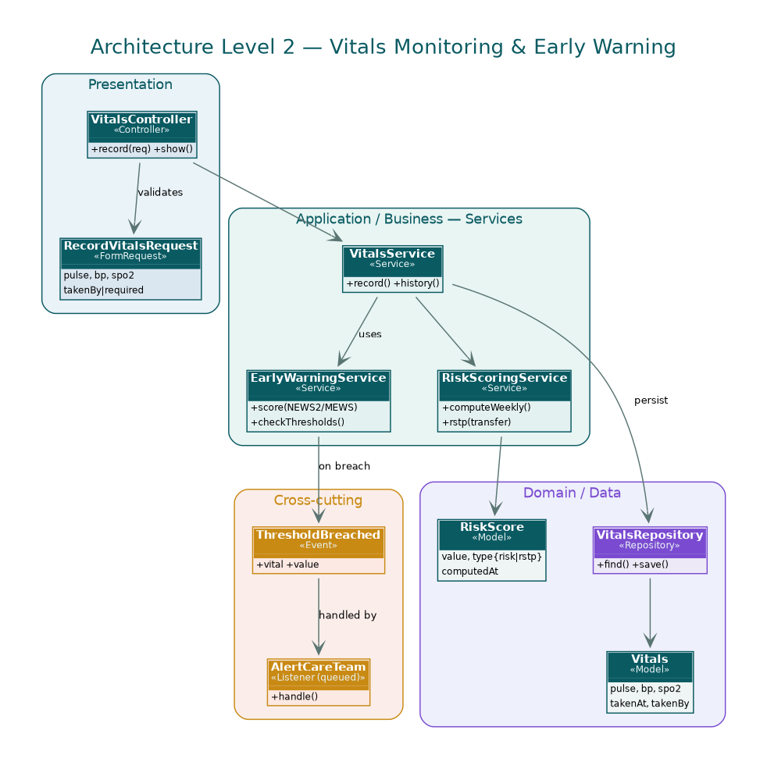
Figure 8. Inside Vitals Monitoring & Early Warning — controllers, services, repositories, and models, with the calls between them.

5.6 Medication Management
What it is for. It handles prescribing, dispensing, giving, and reminding, across the three pharmacies. Priority High; today it is Partial.
Who uses it. Doctor, nurse, pharmacist, patient
FR-6.1 The system shall let a doctor write a prescription (drug, dose, route, frequency, duration) and send it to the pharmacy. [Partial · Q40]
FR-6.2 The system shall keep a medication administration record with status and reminders. [Prototype · Features]
  - Detail: Statuses include “soon” with the next dose time and “taken” with the time given.
FR-6.3 The system shall record discontinued, refused, or unavailable medication. [Not built · Patient file]
FR-6.4 The system shall show the patient their medication, doses, and the day's plan. [Prototype · Features]
FR-6.5 The system should show prescribers what is actually in stock and the alternatives. [Not built · Pharmacy visit]
  - Detail: Today doctors prescribe from memory of what is around; they cannot see stock, amounts, or alternatives.
  - Detail: There are three pharmacies: Emergency/Reception, Outpatient, and Internal Care (location to confirm).
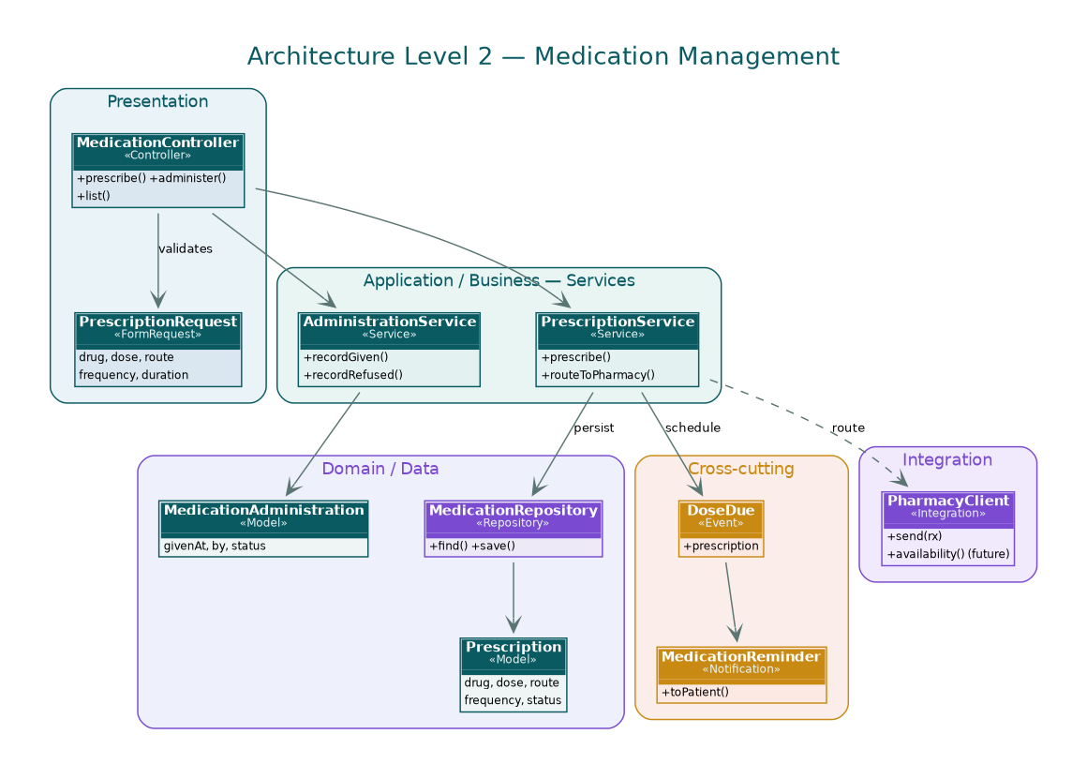
Figure 9. Inside Medication Management — controllers, services, repositories, and models, with the calls between them.

5.7 Diagnostics, Reports & Records
What it is for. It orders tests, brings results back, and keeps the whole record. Priority High; today it is Partial.
Who uses it. Doctor, nurse, lab, radiology, patient
FR-7.1 The system shall let a clinician order lab and radiology tests and send each to the right place. [Partial · Q20]
  - Rules: Lab orders go through DMS; radiology goes to the radiology system.
FR-7.2 The system shall bring lab results back through DMS and radiology results through its system, and put them in front of the treating doctor. [Not built · IT walkthrough]
FR-7.3 The system shall keep the full record across the eleven sections in Section 6.2. [Not built · Patient file record]
  - Detail: Including the transport-safety form (RSTP), the daily-antibiotics sheet, the care plan, the nutrition plan, the Padua VTE score, the doctor's orders, and the consultation request.
FR-7.4 The system shall carry the clinic forms (dental, gyn, pediatric) with structured fields and ICD-10. [Not built · Clinic forms]
  - Detail: The dental form is SMC-F-ALH-008 and includes a consent and a surgical-safety time-out.
FR-7.5 The system shall give the treating doctor the patient's past visits — old diagnoses and prescriptions. [Partial · Clinics doc]
FR-7.6 The system shall run the consultation request (type, clinical detail, requested tests, specialty, signatures). [Not built · Patient file]
FR-7.7 The system shall apply the radiology category that decides who gets films. [Not built · Radiology visit]
  - Detail: Economic pays full and gets films; insurance is discounted and gets no films unless paid; a contracted company has a set discount and pays separately for films.
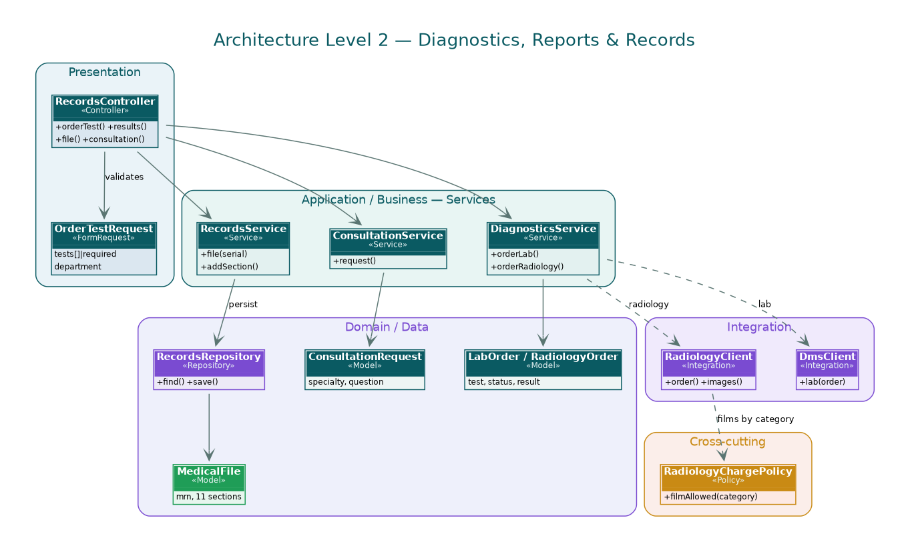
Figure 10. Inside Diagnostics, Reports & Records — controllers, services, repositories, and models, with the calls between them.

5.8 AI Smart Healthcare Assistant
What it is for. An in-app helper for questions, guidance, sorting symptoms by urgency, and escalation. AI, first release. Priority Medium; today it is Not built.
Who uses it. Patient, family, care team
FR-8.1 The system shall answer from hospital-approved content using RAG (after-care, medication, diet, procedures). [Not built · Q2, AI models]
FR-8.2 The system shall sort symptoms by urgency and flag the dangerous ones, and shall not diagnose. [Not built · AI models]
  - Detail: Flags things like chest pain, trouble breathing, bad dizziness.
  - Detail: The answer is an urgency level, not a diagnosis.
FR-8.3 The system shall escalate on a flag — tell a nurse or doctor and hand over to a person. [Not built · AI models]
FR-8.4 The system shall take voice in and speak back. [Not built · Features]
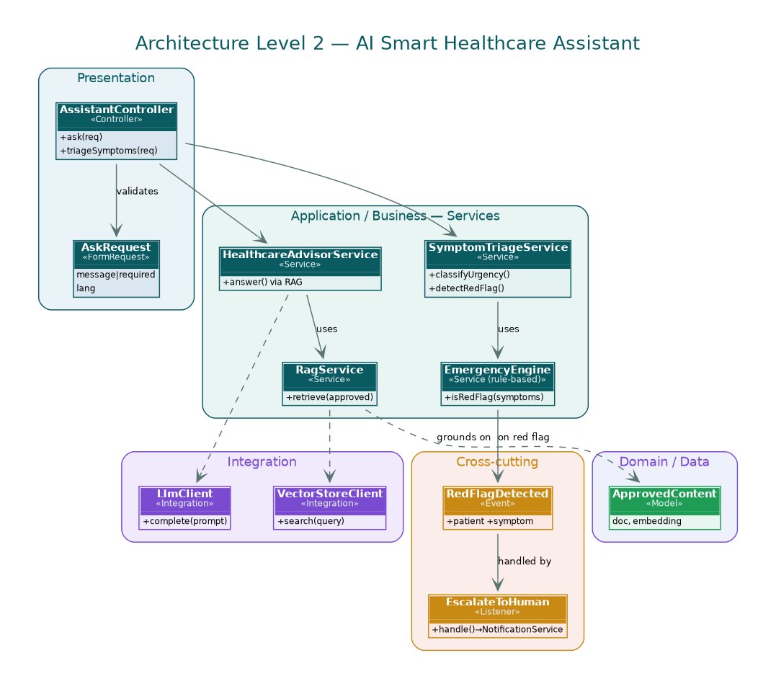
Figure 11. Inside AI Smart Healthcare Assistant — controllers, services, repositories, and models, with the calls between them.

5.9 AI Clinical Documentation & Insights
What it is for. It cuts the writing-up time and turns feedback into something readable. AI, first release. Priority Medium; today it is Not built.
Who uses it. Doctor, nurse, quality manager
FR-9.1 The system shall draft reports (visit summaries, follow-ups, progress notes, discharge summaries) and shall not save one until a doctor approves it. [Not built · AI models]
  - Rules: Nothing is stored until a doctor signs off.
FR-9.2 The system shall turn dictated notes into text in Arabic and English. [Not built · AI models]
  - Detail: Whisper is the suggested engine.
FR-9.3 The system shall translate between Arabic and English for instructions and foreign patients. [Not built · AI models]
FR-9.4 The system shall read patient feedback (sentiment, grouping complaints, pulling out themes) and write the summaries. [Not built · Q73, AI models]
  - Acceptance: A monthly summary names the leading theme, for example waiting time in Emergency.
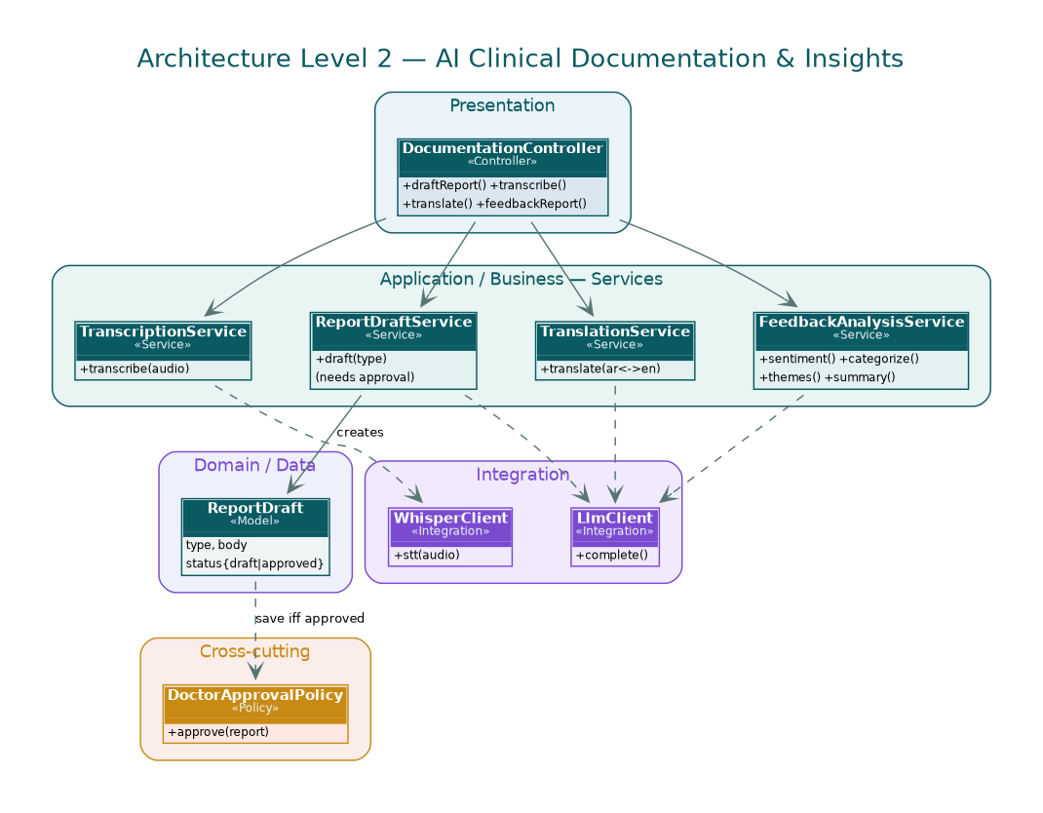
Figure 12. Inside AI Clinical Documentation & Insights — controllers, services, repositories, and models, with the calls between them.

5.10 Notifications, Alerts & Emergency
What it is for. It sends the notifications and runs the ordered escalation from UC-6. Priority High; today it is Partial.
Who uses it. Everyone
FR-10.1 The system shall notify on the chosen channel for appointments, results, plan changes, and stage moves. [Partial · Q14, Features]
FR-10.2 The system shall offer an SOS with an ordered chain of people to reach. [Prototype · Q77]
  - Detail: The order: treating physician, nursing station, family contact, care center.
FR-10.3 The system shall move to the next person after a set wait with no answer. [Not built · Q78]
FR-10.4 The system shall tell a real emergency apart from an ordinary alert. [Not built · Q79]
FR-10.5 The system shall handle a Code Blue on the same chain. [Not built · Q14]
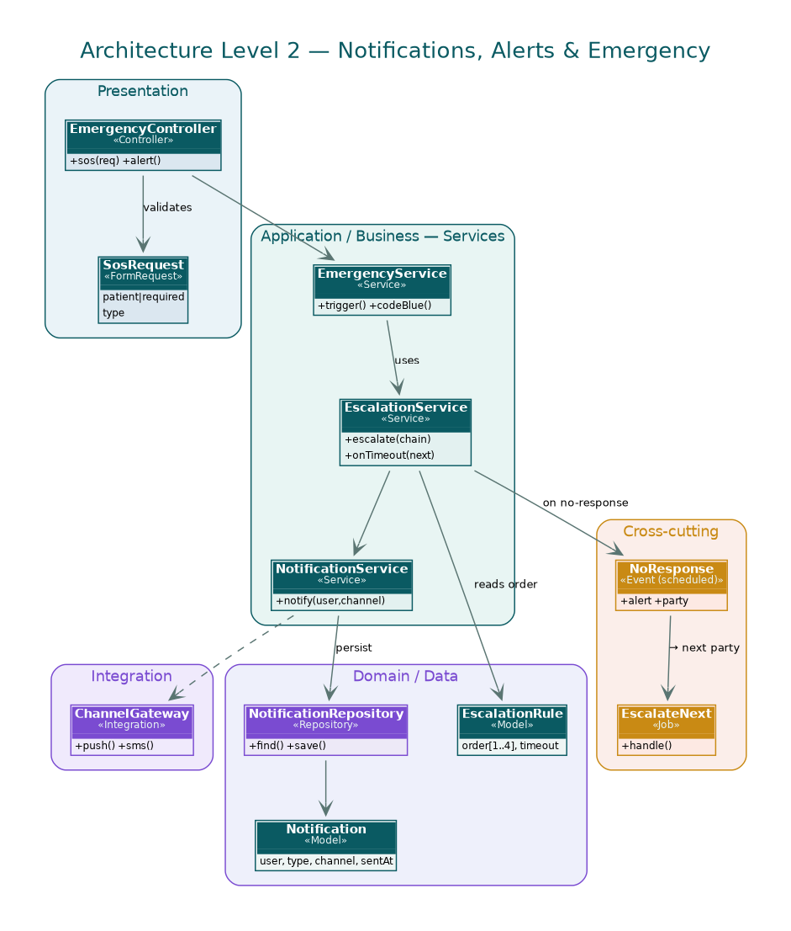
Figure 13. Inside Notifications, Alerts & Emergency — controllers, services, repositories, and models, with the calls between them.

5.11 Family & Caregiver Access
What it is for. It lets a trusted person follow along and act for the patient, inside the privacy rules. Priority Medium; today it is Prototype.
Who uses it. Patient, family
FR-11.1 The system shall link family by QR invite or by hand, and show who is active. [Prototype · Q29]
  - Rules: A cap on how many companions can be linked, set per patient.
FR-11.2 The system shall enforce per-person permissions: see status, get alerts, book, rate, raise an emergency. [Prototype · Q31, Q63]
FR-11.3 The system shall give privacy switches for what family can see. [Prototype · Q30, Q62]
FR-11.4 The system shall tell family about stage moves and big decisions, and ask consent where the hospital needs it. [Prototype · Q32, Q64]
FR-11.5 The system shall keep the family view to status and patient-approved items — family does not see the medical file. [Not built · Reception study]
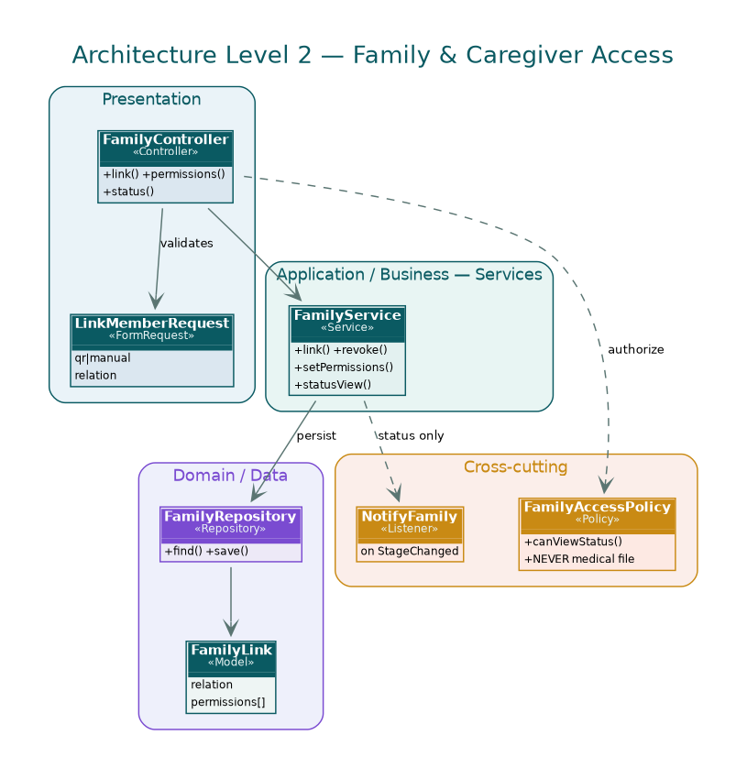
Figure 14. Inside Family & Caregiver Access — controllers, services, repositories, and models, with the calls between them.

5.12 Billing & Financial
What it is for. It works out insurance, takes payment, and closes the financial file. Priority High; today it is Not built.
Who uses it. Patient, receptionist, billing, three-doctor committee
FR-12.1 The system shall work out insurance from the national ID. [Not built · Reception study]
  - Detail: Four answers: insured; has an employer who pays; uninsured but able; uninsured and unable (the decision table is in Section 6.3).
FR-12.2 The system shall send an uninsured, unable case to the three-doctor committee and raise the state-funding memo. [Not built · Reception study]
FR-12.3 The system shall admit a life-threatening case at once, whatever the insurance or the ability to pay, and sort the money out afterwards. [Not built · Reception study]
FR-12.4 The system shall take cash and card, each with its own receipt. [Not built · Reception study]
FR-12.5 The system shall charge for films by the patient's category (see FR-7.7). [Not built · Radiology visit]
FR-12.6 The system shall issue a closing financial file with the itemized cost and invoices at the end. [Not built · Operations pathway]
FR-12.7 The system shall show the patient the bill, the coverage, what is owed, and a way to pay. [Not built · Q7]
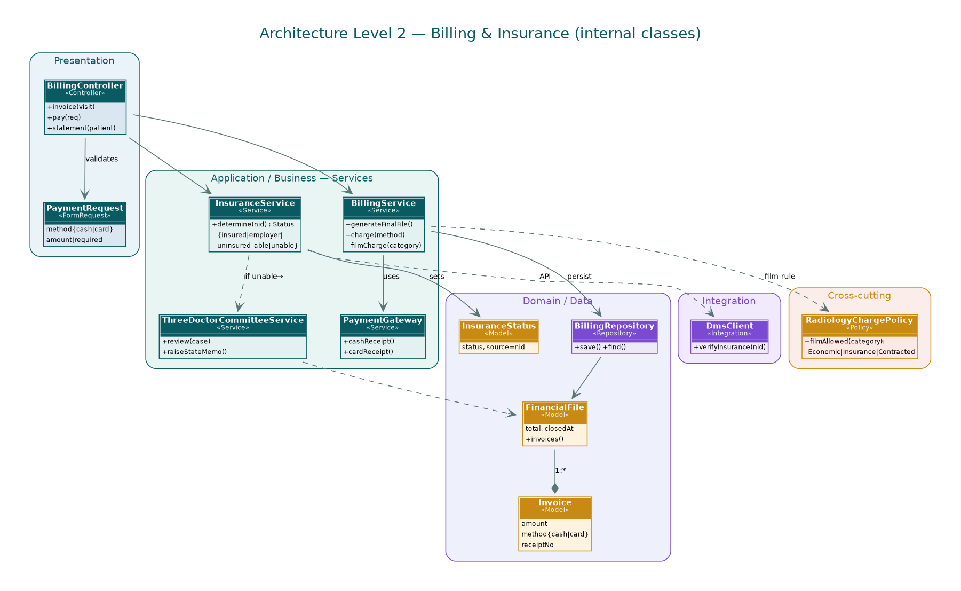
Figure 15. Inside Billing & Financial — controllers, services, repositories, and models, with the calls between them.

5.13 Feedback & Quality Management
What it is for. It picks up feedback at each stage and turns it into something the hospital acts on. Priority High; today it is Prototype.
Who uses it. Patient, family, quality manager, department head
FR-13.1 The system shall let the patient, or someone for them, rate each finished stage one to five with an optional note. [Prototype · Q65, Q66, Q68]
FR-13.2 The system shall let a user report a problem tied to the current stage and send it to the unit supervisor as a numbered ticket. [Prototype · Features]
FR-13.3 The system shall send negative feedback to the right department head. [Not built · Q67]
FR-13.4 The system shall hold a response window on complaints and escalate to the director when it is missed. [Not built · Q70]
  - Detail: For example: reply within 48 hours, then escalate.
FR-13.5 The system shall show a quality view with the average rating, the worst points, and the open complaints. [Not built · Q69]
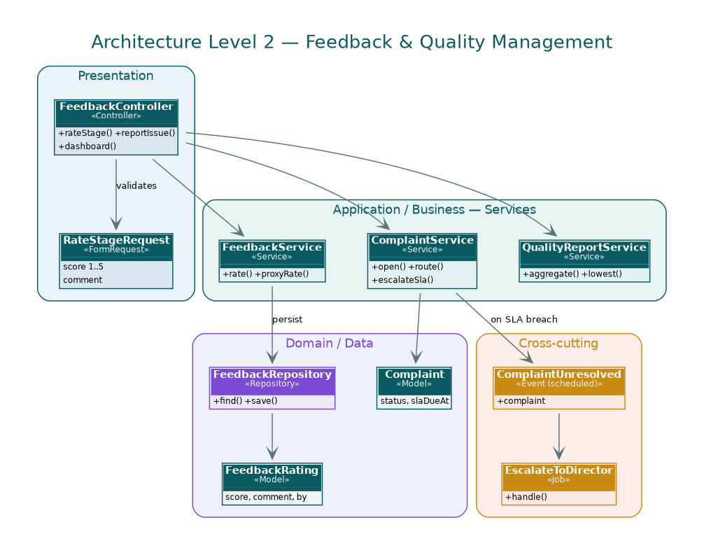
Figure 16. Inside Feedback & Quality Management — controllers, services, repositories, and models, with the calls between them.

5.14 Education, Engagement & Loyalty
What it is for. It teaches, reassures, and gives a little reward for taking part. Priority Low; today it is Prototype.
Who uses it. Patient, family, quality (approval)
FR-14.1 The system shall offer a video library (the procedure, recovery, medication safety). [Prototype · Features]
FR-14.2 The system shall offer calm content for the patient and the waiting family. [Prototype · Q28]
FR-14.3 The system shall give Care Points for taking part, with a path to a reward such as priority booking. [Prototype · Features]
FR-14.4 The system shall not publish any medical or educational content until the quality head approves it. [Not built · Q19]
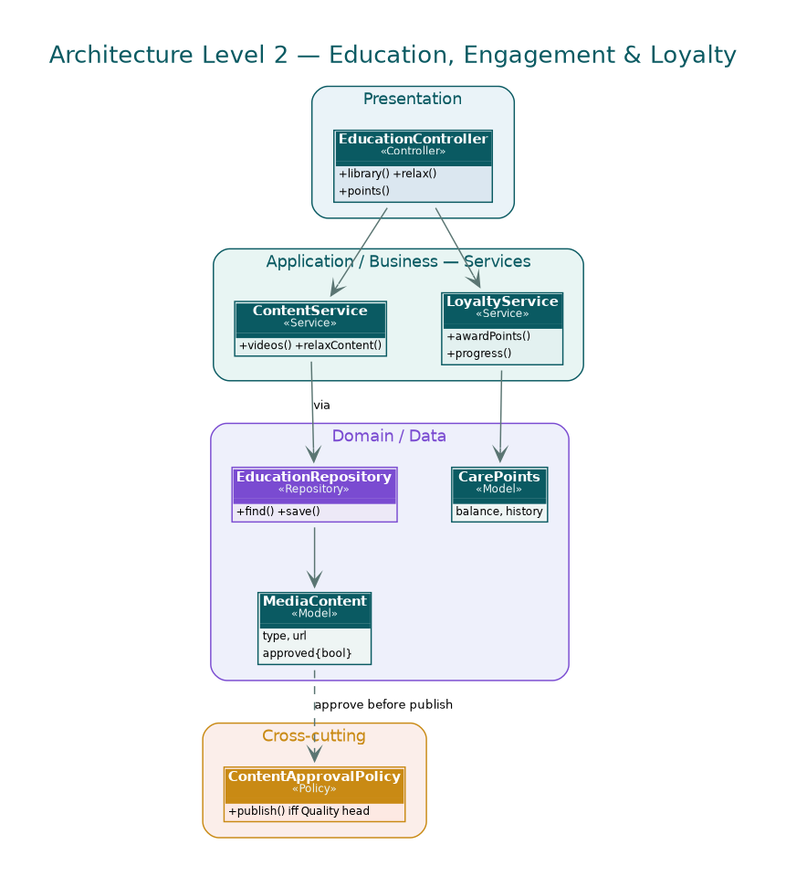
Figure 17. Inside Education, Engagement & Loyalty — controllers, services, repositories, and models, with the calls between them.

5.15 Administration, Reporting & Integration
What it is for. It runs the accounts, the reports, and the links to the other systems. Priority High; today it is Not built.
Who uses it. System admin, hospital director, quality, IT
FR-15.1 The system shall let the IT admin make accounts and set permissions. [Not built · Q51]
FR-15.2 The system shall show the management numbers, including patient counts, average stage times, Door-to-Balloon, and a department comparison. [Not built · Q72, Q76]
  - Detail: Door-to-Balloon is the hospital's main cardiac quality number and has to be on the management screen.
FR-15.3 The system shall send out scheduled reports (monthly, say) to a set list. [Not built · Q73–Q75]
FR-15.4 The system shall link to DMS for registration, appointments, the record, clinical notes, and admin, through the bought APIs. [Not built · IT walkthrough]
FR-15.5 The system shall link the lab (via DMS), radiology (its own system), and the pharmacy (DMS, half-manual). [Not built · IT walkthrough]
FR-15.6 The system shall run over the LAN with an IP whitelist and an external server, working off dummy-data API docs until the real APIs are there. [Not built · IT walkthrough]
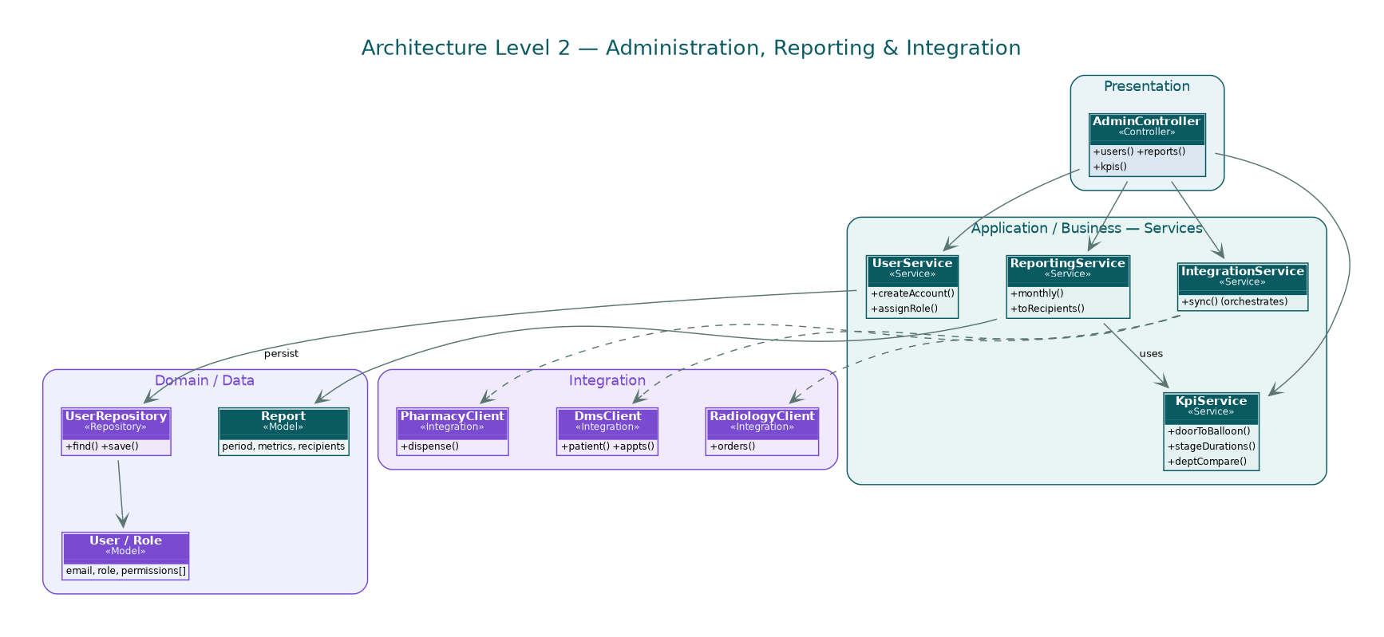
Figure 18. Inside Administration, Reporting & Integration — controllers, services, repositories, and models, with the calls between them.

5.16 Indoor Navigation & Hospital Map
What it is for. It helps people find their way around the building. New. Priority Low; today it is Not built.
Who uses it. Patient, family, guest
FR-16.1 The system shall show an interactive floor-by-floor map with colored zones and zoom. [Not built · Features]
FR-16.2 The system shall show a live “you are here” using BLE beacons or Wi-Fi. [Not built · Features]
FR-16.3 The system shall let someone search a room, doctor, department, or service and show distance and time. [Not built · Features]
FR-16.4 The system shall give turn-by-turn directions inside, with an accessible-route option. [Not built · Features]
FR-16.5 The system shall link to the map from an appointment, a stage, or a doctor's profile. [Not built · Features]
FR-16.6 The system shall show the useful spots (restrooms, prayer rooms, cafeteria, pharmacy, ATM, parking). [Not built · Features]
FR-16.7 The system shall offer a visitor map mode with no login, and no patient location unless it is granted. [Not built · Features]
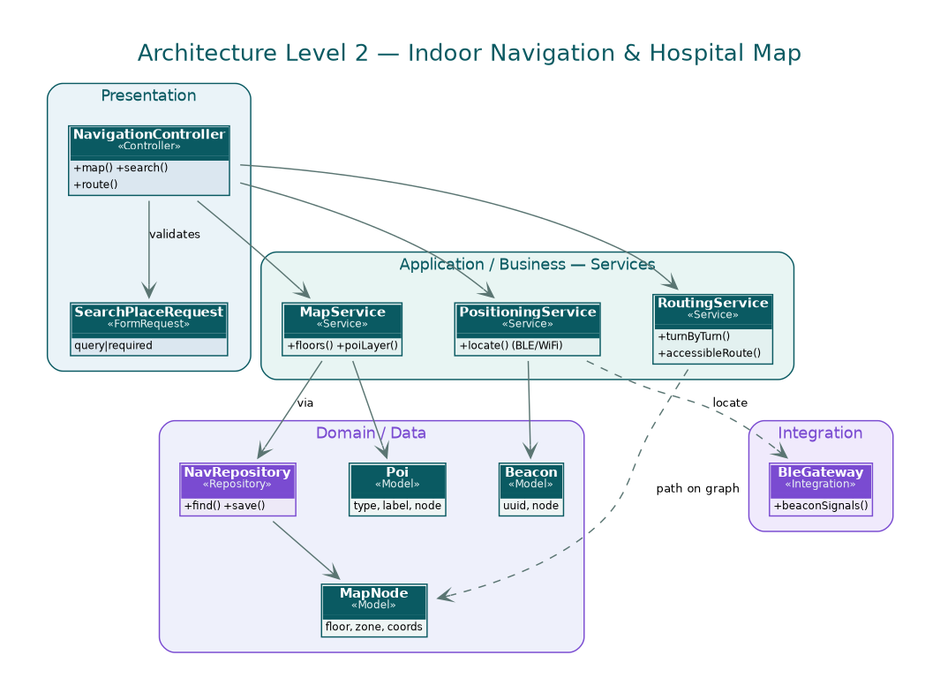
Figure 19. Inside Indoor Navigation & Hospital Map — controllers, services, repositories, and models, with the calls between them.

5.17 Accessibility
What it is for. It makes sure everyone can actually use the app. New. Priority Medium; today it is Not built.
Who uses it. Every patient, including those who cannot see, hear, or speak, and the elderly
FR-17.1 The system shall support vision needs: high contrast, a font scaler, bold text, less motion, and full screen-reader labels in a sensible order. [Not built · Features]
FR-17.2 The system shall support voice: commands, voice in and out for the advisor, audio alerts, and a voice SOS. [Not built · Features]
FR-17.3 The system shall guide a blind user indoors with audio, haptics, beacon call-outs, and a voice-only “guide me” mode. [Not built · Features]
FR-17.4 The system shall support hearing needs: captions on every video, visual and haptic alerts, a sign-language card, and text to a nurse. [Not built · Features]
FR-17.5 The system shall support motor needs: switch access, big targets, a one-hand mode, and buttons instead of swipes. [Not built · Features]
FR-17.6 The system shall keep accessibility profiles (default, low vision, blind, deaf, motor) tied to the account. [Not built · Features]
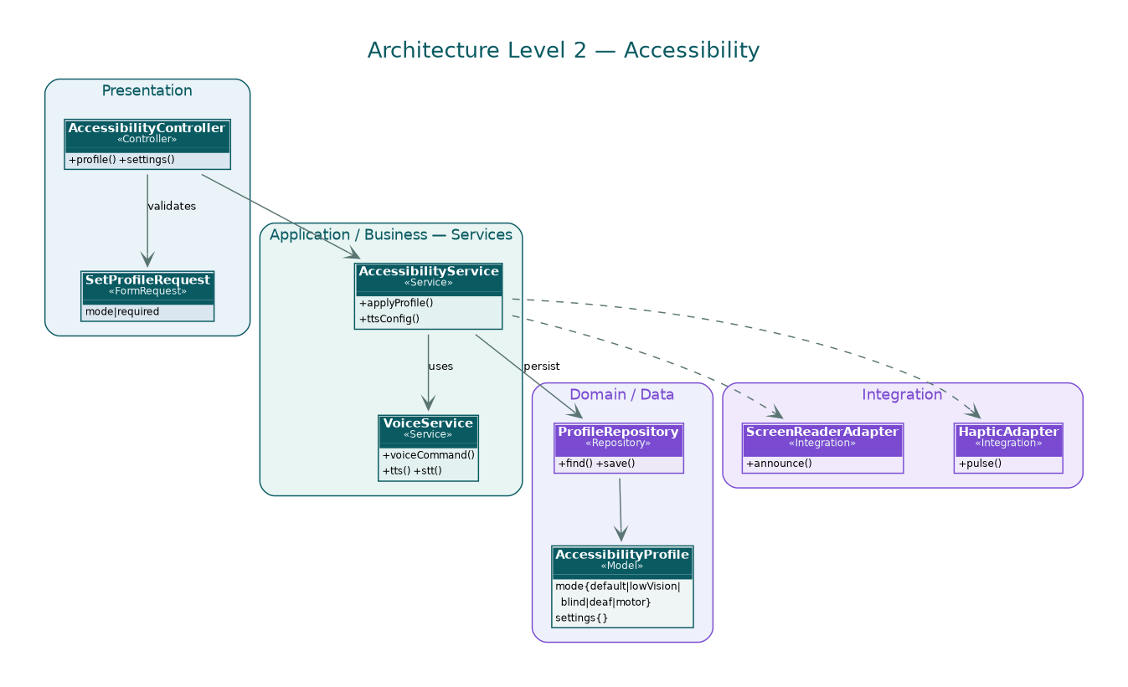
Figure 20. Inside Accessibility — controllers, services, repositories, and models, with the calls between them.

6. The data

6.1 What reception collects (the same in Emergency and Outpatient)
Field | Where it comes from | Note
Full name | Patient / family
National ID | Patient / family | The basis for the Serial and the insurance check
Date of birth | Patient / family
Age | Patient / family
Address | Patient / family
Insurance status | System | Worked out from the national ID
Medical file (new or existing) | System (by Serial)
Personal history | Patient / family / old records
Pulse | Nurse | Vital
Blood pressure | Nurse | Vital
SpO2 | Nurse | Vital — feeds the risk score

The two cards
 | Arrival card | Booking card
When | On arrival | Once booked
Copies | One | Several
What is on it | serial, registration no., name, date/time, barcode | serial, age, date of birth, name, barcode
For | Tying the patient to the system on arrival | Following the patient and samples after booking

6.2 The patient file — eleven sections
# | Section | Main contents
1 | Basic information | Name, MRN, admission/discharge times, doctor, department
2 | Admission & discharge summary | Demographics, reason, length of stay, final diagnosis + ICD, comorbidities, procedures, condition at discharge, recommendations
3 | Personal history | Habits, allergies, past reactions, complaint, past medical and surgical history, family and social history, systems review, current medication
4 | Internal transport safety (RSTP) | Staff, method, risk level and RSTP, hemodynamic / respiratory / neurological status, support
5 | Daily antibiotics | Sample, culture, date, reason, dose/route/duration, pharmacy notes, signatures
6 | Medication & administration | Drug, dose, days, route, frequency, instructions, signatures, and the refused/unavailable record
7 | Multidisciplinary care plan | Problem list, allergies/interventions, outcomes, time frame, plan and signature
8 | Nutritional care plan | Assessment, needs, the diet, enteral/parenteral/ONS, monitoring, discharge advice
9 | VTE risk (Padua) | Factors, Padua total, result, prophylaxis
10 | Doctor's orders | Medication, lab, imaging, nursing and monitoring instructions, diet, activity, procedures, status
11 | Consultation request | Type, clinical detail, requested tests, specialty, signatures
The clinic forms (dental, gyn, pediatric) carry their own fields — patient data, history, examination, plan, tests, medication, education, follow-up, referral — and the dental form (SMC-F-ALH-008) adds the consent and the surgical time-out.

6.3 The decisions, as tables

Triage
What is seen | Class | Where they go
Not urgent, clinics open | Cold | The right clinic
Not urgent, clinics closed | Cold | Reception
Urgent | Emergency | Emergency Department
Unconscious / accident / life-threatening | Critical | Straight to Emergency, skipping triage

Insurance
Answer | What happens
Insured | Carries on normally
Has an employer who pays | Carries on normally
No insurance, can pay | Patient pays; carries on normally
No insurance, cannot pay | Committee reviews; a memo goes up for state funding
Any of these, life-threatening | Admitted at once; money handled afterwards

Escalation
Order | Who | When
1 | Treating physician | First
2 | Nursing station | No answer in the set wait
3 | Family contact | Still no answer
4 | Care center | Last resort

6.4 The journey, as states
Stage | Owner | Comes in with | Leaves when
Arrival / reception | Receptionist | Identity, Serial, insurance | File open, card issued
Triage | Head nurse | Vitals, complaint | A class is set
ER exam | ER physician | Vitals, history | Specialty decided
Specialty / diagnosis | Specialist | Echo, ECG, results | Treatment decided
Cath prep (cold) | Surgeon, nurse | Requisition, risk score | Scheduled
Catheterization | Cath-lab team | Schedule | Procedure done, Door-to-Balloon recorded
Recovery / ICU | Nurse, physician | Procedure outcome | Stable
Ward | Nurse, physician | Care plan | Ready to leave
Discharge | Physician | Criteria met | Instructions and follow-up given
Home follow-up | Follow-up unit | Discharge file | First appointment set

6.5 The classes
This is the full class model: every class across the seventeen subsystems, grouped by package, from the controllers and form requests at the top down through the services and repositories to the models — levels 0 to 3 — each with its methods. Inside a package the arrows show the path a call takes, controller to service to repository to model. The calls that cross between subsystems are the ones drawn in the Level 1 and Level 2 diagrams. It is a wide reference sheet, so it reads best zoomed in the SVG.
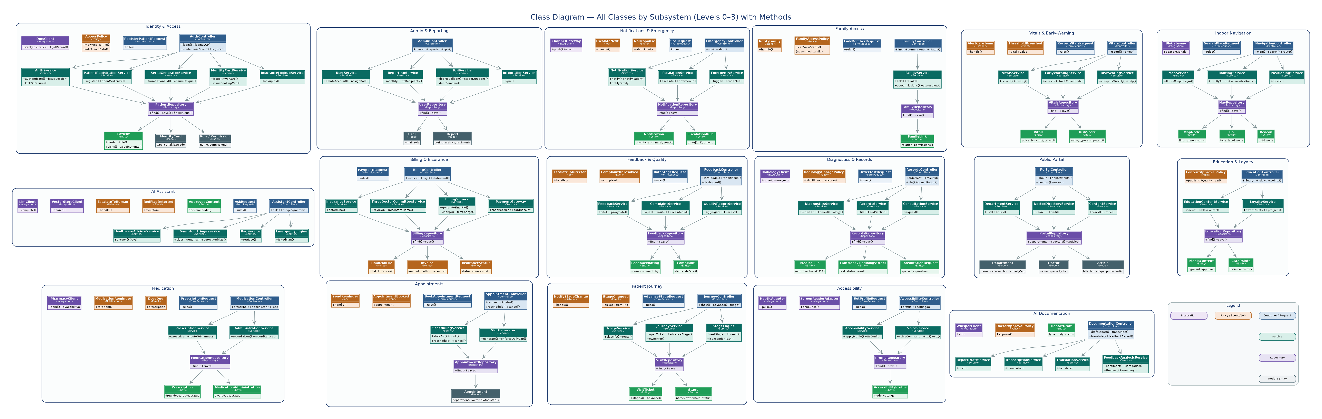
Figure 21. The complete class model — all classes by subsystem, with their methods.

7. The qualities it has to have

7.1 Speed
- NFR-1 — It shall feel responsive over the hospital LAN under normal clinic and emergency load.

7.2 Safety
- NFR-2 — AI drafts wait for a doctor before they are saved; the advisor does not diagnose and hands red flags to a person.

7.3 Security and privacy
- NFR-3 — The medical file is for the treating doctor and the nursing supervisor; reception sees admin only; a department sees only its own part.
- NFR-4 — Encrypted credentials, controlled sessions, lockout after repeated failures, and the application reachable only through the IP whitelist.
- NFR-5 — Sensitive data shows only to the right roles and the patient's chosen companion; consent is recorded and kept.

7.4 Up and reliable
- NFR-6 — The emergency features are there 24/7.

7.5 Easy to use, for everyone
- NFR-7 — Plain enough for a largely local, tribal, working population; pictures over walls of text.
- NFR-8 — It meets the accessibility requirements in Section 5.17.

7.6 Works with the rest, in two languages
- NFR-9 — Arabic and English (and Russian where the existing scope needs it), led by the patient's choice.
- NFR-10 — It links to DMS and radiology through the bought APIs and stands as the source of truth where there are none yet.

7.7 Traceable
- NFR-11 — Every view or edit of clinical data is logged with who, what role, and when, and the self-edit window is enforced.

8. The rules of the house
ID | Rule
BR-1 | Insurance is read off the national ID: insured, employer-paid, uninsured-able, or uninsured-unable.
BR-2 | A life-threatening patient is admitted at once, money or no money; it is settled later.
BR-3 | The medical file is for the treating doctor and the nursing supervisor; family cannot see it; a department sees only its own part.
BR-4 | Reception handles admin only and never edits anything medical.
BR-5 | The Serial is made from the national ID and reused across visits.
BR-6 | The ambulance radio call and its vitals are not recorded or trusted; vitals are taken again in the ER.
BR-7 | The risk score is redone every week through the wait and the stay.
BR-8 | No operation is booked without a prior examination here.
BR-9 | Medical and educational content is published only after the quality head approves it.
BR-10 | Whether a patient gets their films depends on their category: economic, insurance, or contracted company.

9. Tracing it back, and what is still open

9.1 From the customer's wish to the requirement
Every requirement in Section 5 names its source. The customer's original wishes map onto them like this.
ID | What they wanted | Met by
CR-1 | Patients follow their whole visit from a phone. | FR-4.x
CR-2 | Patients can ask an AI advisor. | FR-8.x
CR-3 | The team is warned early when a patient slides. | FR-5.x
CR-4 | Staff run their patients and notes from a dashboard. | FR-4/5/7/9/13
CR-5 | Patients book and move appointments. | FR-3.x
CR-6 | One trusted person can follow and act, with permission. | FR-11.x
CR-7 | Patients see the bill and pay. | FR-12.x
CR-8 | Patients rate every stage; it becomes reports. | FR-13.x
CR-9 | Faster notes with AI drafts, voice, and translation — doctor-approved. | FR-9.x
CR-10 | Everyone can use it, including sensory, elderly, and other-language patients. | FR-17.x
CR-11 | Arabic and English (Russian where needed). | NFR-9
CR-12 | Visitors look around and book without an account. | FR-2.x
CR-13 | People find their way inside. | FR-16.x
CR-14 | In an emergency the right people are reached, in order. | FR-10.x
CR-15 | It works with DMS rather than replacing it. | FR-15.4, NFR-10
CR-16 | Data stays private; only the right people and the chosen companion see the sensitive parts. | FR-1.8, NFR-3/5
CR-17 | Management reads the quality and performance reports. | FR-13.5, FR-15.2

9.2 Still to confirm with the hospital / IT
# | Question | Touches
1 | Is the risk score worked out by the system, or typed in by the nurse? | FR-5.4
2 | Is the Outpatient Serial the same as the Emergency one for a patient, or separate? | FR-1.4
3 | For ambulance cases, is the report saved before the patient comes in? | FR-4.4 / 7.2
4 | Confirm the radiology system's name (“Milestone”?) and how we talk to it. | 3.3 / FR-15.5
5 | Where is the third (Internal Care) pharmacy? | FR-6.5

10. API contract (v1)
The clients talk to a versioned REST API under /api/v1. Every call returns JSON and carries a Bearer token (Laravel Sanctum), except the login calls. The tables below list the endpoints by subsystem — method, path, whether they need a token, and what they do. The full request and response bodies live in the Postman collection that ships with this document (ABCDE_API.postman_collection.json): import it, set baseUrl and token in the collection variables, and the examples are ready to run.

10.1 Authentication & Identity
Method | Path | Auth | Purpose
POST | /auth/login | Public | Log in by mobile/file ID + password (FR-1.1).
POST | /auth/login/qr | Public | QR login resolving to the patient Serial (FR-1.2).
POST | /auth/logout | Bearer | Invalidate the session.
POST | /patients/register | Bearer | Create patient + generate Serial from national ID (FR-1.4).
GET | /patients/{serial} | Bearer | Read a patient by Serial.
PUT | /patients/{serial}/preferences | Bearer | Language, contact, decision-maker (FR-1.6).
POST | /patients/{serial}/cards | Bearer | Issue arrival/booking card (FR-1.5).

10.2 Public Portal
Method | Path | Auth | Purpose
GET | /public/hospital | Public | Public profile (FR-2.1).
GET | /public/departments | Public | Departments + hours (FR-2.2).
GET | /public/doctors?specialty=cardiology&q= | Public | Searchable directory (FR-2.3).
GET | /public/news | Public | News + patient stories (FR-2.4).

10.3 Appointments
Method | Path | Auth | Purpose
POST | /appointments | Bearer | Create a request (FR-3.1).
GET | /appointments?patientSerial=ALH-000123 | Bearer | Upcoming appointments (FR-3.3).
GET | /appointments/slots?department=Cardiology&date=2026-06-10 | Bearer | Slots from working hours (FR-3.2).
PATCH | /appointments/{id}/reschedule | Bearer | Move before the cut-off (FR-3.4).
DELETE | /appointments/{id} | Bearer | Cancel within rules (FR-3.4).

10.4 Patient Journey
Method | Path | Auth | Purpose
POST | /visits | Bearer | Open a visit ticket (FR-4.1).
POST | /visits/{id}/triage | Bearer | Classify + route (FR-4.2).
GET | /visits/{id} | Bearer | Read the journey state.
POST | /visits/{id}/advance | Bearer | Move to next stage (FR-4.6).

10.5 Vitals & Early Warning
Method | Path | Auth | Purpose
POST | /visits/{id}/vitals | Bearer | Manual vitals + score (FR-5.1, FR-5.3).
GET | /visits/{id}/vitals | Bearer | Trend (FR-5.1).
GET | /visits/{id}/risk-score | Bearer | Current score (FR-5.4).
POST | /visits/{id}/risk-score/recompute | Bearer | Weekly recompute / RSTP (FR-5.4).

10.6 Medication
Method | Path | Auth | Purpose
POST | /visits/{id}/prescriptions | Bearer | Create + route to pharmacy (FR-6.1).
GET | /visits/{id}/prescriptions | Bearer | MAR list (FR-6.4).
POST | /prescriptions/{id}/administer | Bearer | Record given/refused (FR-6.2, FR-6.3).
GET | /pharmacy/availability?drug=Aspirin | Bearer | Real-time stock (future, FR-6.5).

10.7 Diagnostics & Records
Method | Path | Auth | Purpose
POST | /visits/{id}/orders | Bearer | Order lab/radiology (FR-7.1).
GET | /visits/{id}/orders | Bearer | Orders + status.
GET | /visits/{id}/results | Bearer | Results via DMS/radiology (FR-7.2).
GET | /patients/{serial}/file | Bearer | Full 11-section file (FR-7.3).
POST | /visits/{id}/consultations | Bearer | Consultation workflow (FR-7.6).

10.8 AI Assistant
Method | Path | Auth | Purpose
POST | /assistant/ask | Bearer | RAG answer (FR-8.1).
POST | /assistant/triage | Bearer | Urgency + red flags (FR-8.2).

10.9 AI Documentation
Method | Path | Auth | Purpose
POST | /documentation/draft | Bearer | Draft report, needs approval (FR-9.1).
POST | /documentation/{draftId}/approve | Bearer | Doctor approval before save (FR-9.1).
POST | /documentation/transcribe | Bearer | Speech to text (FR-9.2).
POST | /documentation/translate | Bearer | AR<->EN translation (FR-9.3).

10.10 Notifications & Emergency
Method | Path | Auth | Purpose
POST | /emergency/sos | Bearer | Ordered escalation (FR-10.2).
GET | /notifications | Bearer | Inbox (FR-10.1).
POST | /notifications/{id}/read | Bearer | Mark a notification read.

10.11 Family & Caregiver
Method | Path | Auth | Purpose
POST | /patients/{serial}/family | Bearer | Link family (FR-11.1, FR-11.2).
GET | /patients/{serial}/family | Bearer | Linked members.
PATCH | /family/{id}/permissions | Bearer | Per-member permissions (FR-11.2).
DELETE | /family/{id} | Bearer | Remove a companion.

10.12 Billing & Insurance
Method | Path | Auth | Purpose
GET | /patients/{serial}/insurance | Bearer | Auto from national ID (FR-12.1).
POST | /visits/{id}/billing/committee-review | Bearer | Three-doctor committee + memo (FR-12.2).
GET | /visits/{id}/financial-file | Bearer | Closing file (FR-12.6).
POST | /visits/{id}/payments | Bearer | Cash/card payment (FR-12.4).

10.13 Feedback & Quality
Method | Path | Auth | Purpose
POST | /stages/{id}/feedback | Bearer | Rate a finished stage (FR-13.1).
POST | /complaints | Bearer | Open a complaint (FR-13.2).
GET | /quality/dashboard | Bearer | Quality view (FR-13.5).

10.14 Education & Loyalty
Method | Path | Auth | Purpose
GET | /education/videos | Bearer | Approved videos (FR-14.1).
GET | /education/relax | Bearer | Calm content (FR-14.2).
GET | /patients/{serial}/care-points | Bearer | Loyalty (FR-14.3).

10.15 Admin & Reporting
Method | Path | Auth | Purpose
POST | /admin/users | Bearer | Create account (FR-15.1).
PATCH | /admin/users/{id}/role | Bearer | Adjust permissions (FR-15.1).
GET | /reports/kpis | Bearer | Door-to-Balloon + KPIs (FR-15.2).
GET | /reports/monthly?month=2026-05 | Bearer | Scheduled report (FR-15.3).

10.16 Indoor Navigation
Method | Path | Auth | Purpose
GET | /nav/map?floor=1 | Bearer | Floor map (FR-16.1).
GET | /nav/search?q=cardiology | Bearer | Search (FR-16.3).
GET | /nav/route?from=ENT-1&to=C-12&accessible=true | Bearer | Turn-by-turn (FR-16.4).

10.17 Accessibility
Method | Path | Auth | Purpose
GET | /patients/{serial}/accessibility | Bearer | Read profile (FR-17.6).
PUT | /patients/{serial}/accessibility | Bearer | Apply profile (FR-17.1-6).

10.18 Integration (server-to-server)
These run outbound over the LAN through the vendor APIs once they are bought, so they are not part of the client collection.
System | Operations | Notes
DMS | verifyInsurance(nationalId), getPatient, syncAppointment, pushClinicalNote | Bought vendor APIs over LAN; IP-whitelisted.
Lab (via DMS) | sendOrder, getResult | Through DMS.
Radiology (Milestone?) | sendOrder, getReport, getImages | Separate system; respects film category.
Pharmacy | sendPrescription, getAvailability (future) | DMS-connected, partly manual.

